A Project Report
on
“AI Recruiter – Shortlist a Suitable candidate for specific Job role (Using IBM Watson Assistant)”

By

P. SAI SAVITHRU MOHAN

UNDER THE GUIDANCE OF

SMARTBRIDGE
 | CONTENTS
 |  | Page no.
 | 1. INTRODUCTION | 3
 | 1.1 Overview
 | 1.2 Purpose
 | 2. LITERATURE SURVEY | 5
 | 2.1 Existing Problem
 | 2.2 Proposed Solution
 | 3. THEORETICAL ANALYSIS | 6
 | 3.1 Block Diagram
 | 3.2 Hardware / Software Designing
 | 4. EXPERIMENTAL INVESTIGATIONS | 7
 | 5. FLOW CHART | 12
 | 6. RESULTS | 13
 | 7. ADVANTAGES & DISADVANTAGES | 17
 | 8. APPLICATIONS | 18
9. CONCLUSION 19
10. FUTURE SCOPE 20
11. BIBILOGRAPHY 20

CHAPTER 1

INTRODUCTION

1.1 OVERVIEW

With the breakthrough of emerging technologies like Artificial Intelligence (AI), Data Science, Data Analytics, Cloud Computing, Internet of Things (IoT), Machine Learning, a large number of job opportunities are created these days and a lot more are expected in the future. Hence choosing the right candidate for right work has become very important and a key factor for the welfare and harmony of the organizations. But interacting, interviewing and screening the right candidate became a very difficult job for the Recruiters and Human Resources (HRs).

Artificial Intelligence enabled and empowered bots can definitely stand as a solution for this problem and moreover, saves energy, time and money for the recruiters and the recruiting companies as well. Artificial Intelligence enabled and empowered recruiter, AI Recruiter can interact with a very large number in very small duration of time with high accuracy and stands as a helping hand for the recruiters in selecting the right candidate for the job. It uses the most efficient and interactive Artificial Intelligence (AI) service, IBM Watson Assistant, for building a conversation with the user or candidate. This project deals with the efficient way of implementing this service to develop a conversational bot that can be used for screening the candidates and choosing the right bunch for interview or job directly.

- Project Requirements and Skills Required: Java Script Object Notation (JSON) and IBM Watson Assistant.
- Functional Requirements: IBM Cloud (Account).
- Technical Requirements: Java Script Object Notation (JSON), IBM Watson Service.
- Software Requirements: IBM Services.
- Project Category: Artificial Intelligence.
- Project Deliverables: AI Recruiter that could shortlist eligible candidates for specific job.
- Project By: Pishka Sai Savithru Mohan.

1.1.1 SCOPE OF WORK
- Create a Recruiter dialog skill in Watson Assistant.
- Build logic for interacting and screening the eligible candidates.
- Creating Assistant for the Recruiter dialog skill and generating a preview link.

1.2 PURPOSE

With the increasing number of job-seekers in different industries it has become a hectic and colossal task for the recruiters or the employers to hire the suitable and eligible candidate to get their work done. Recruiters can interview each applied candidate but it consumes a lot of time, energy and money. Sometimes the situation gets even more complicated when candidates to be interviewed are in very large numbers and just becomes impossible for the employer or recruiter to pick the right candidate. In such situations, AI Recruiter comes into play and becomes handy for recruiters. These AI enabled recruiters can interact with any number of candidates and identify the skills of candidate and can screen the candidates for having a final interview with recruiter or hiring them directly based upon the insights this AI Recruiter brings. This project thus serves to solve the issue in screening or short-listing the candidates for specific job role.

CHAPTER 2

LITERATURE SURVEY

2.1 EXISTING PROBLEM

The key factor for the success and welfare of any organization or industry is their employees. In the quest of picking the right employees, organizations are spending a lot of time, money and energy. The recruiters and employers find it impossible when the number of candidates to be interviewed is quite large. Though few organizations use screening systems, these can sometimes be manipulated by stuffing with a lot of keywords. And moreover there is no proper methodology or system to screen the candidates by asking them different set of questions depending upon the candidate’s reply and few existing solutions (systems or methodologies) cannot make their own judgements and bring insights like a human recruiter can do in the interview.

2.2 PROPOSED SOLUTION

The solution for interviewing a large number of candidates who applied for a specific job without the involvement of recruiters and employers is AI Recruiter. This project serves to solve this issue. Moreover, AI Recruiter can make its own independent decisions depending upon the user answers and question them accordingly and also brings insights about the candidate that the recruiter can use and review if needed. The heart of AI Recruiter is IBM Watson Assistant. It can interact with candidates as usual humans do and switch questions depending upon the candidates’ response and screen the right candidates for further rounds or interview by judging the worth of the candidate on its own once trained and also provides us a user-friendly user interface (UI) and helps the candidates express themselves without any barriers.

CHAPTER 3

THEORETICAL ANALYSIS

3.1 BLOCK DIAGRAM
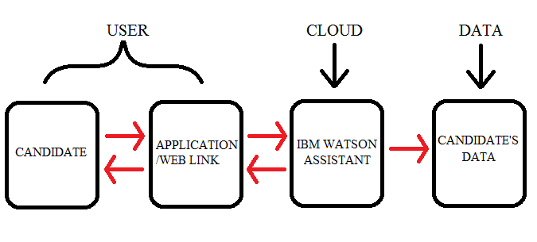
Fig. 3.1 Block Diagram of Artificial Intelligence(AI) Recruiter

1. The candidate gets involved in the conversation with IBM Watson Assistant using Web link.
2. The web/link application converses with user based upon the flow of IBM Watson Assistant and asks questions depending upon the candidate’s response.
3. Candidate’s information and skills will be stored and judgements will be taken.

3.2 HARDWARE / SOFTWARE DESIGNING

1. Create ‘IBM Cloud Service’ Account.
2. Create Watson Assistant Service.
3. Build a Dialog skill and configure it with Assistant.
4. Generating Preview link.

CHAPTER 4

EXPERIMENTAL INVESTIGATIONS

4.1 CREATING IBM CLOUD SERVICE
Once we create an IBM Cloud Account the next important step required to develop an Artificial Intelligence Recruiter involves the following step:
- Creation of Watson Assistant.

4.1.1 CREATION OF WATSON ASSISTANT
1. Open Catalog and search Watson Assistant and then click on it and then click Create.
2. In Resources, find Watson Assistant and the click on it.
3. In the Assistant page, find Launch Watson Assistant in Manage tab and click on it.
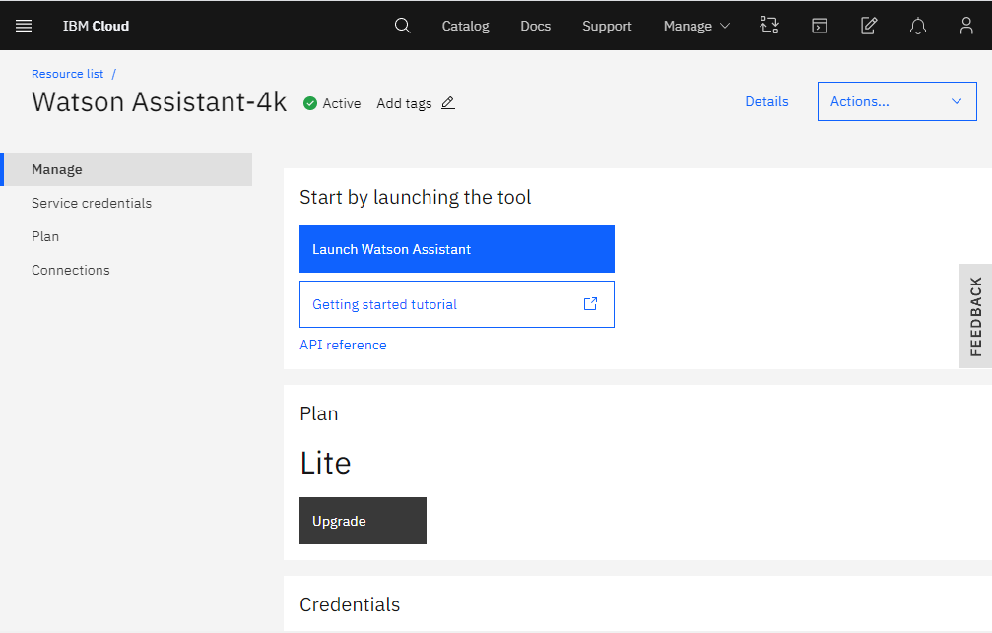

4. Click on Create Assistant and name your Assistant and click Create assistant.
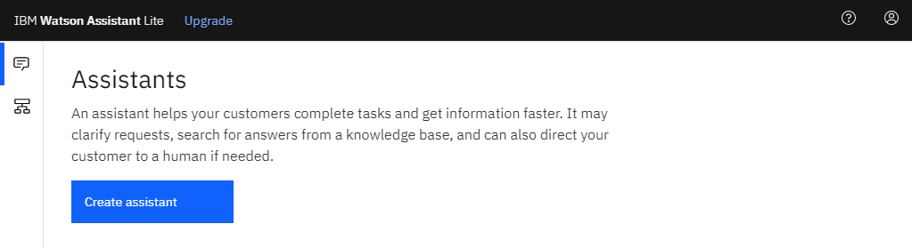

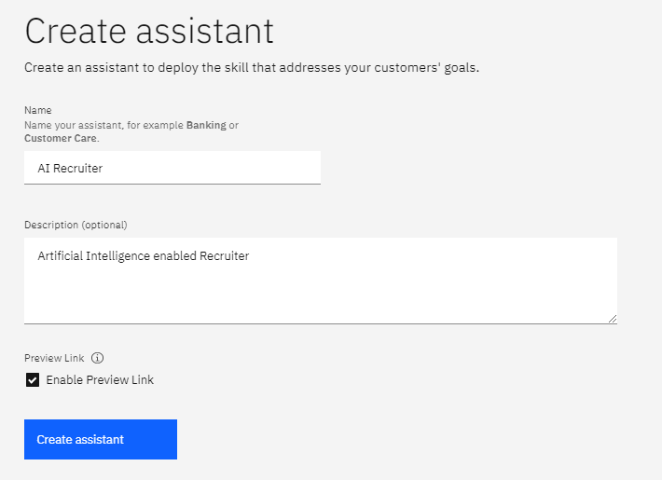

5. Then click on Add dialog skill and name the dialog skill.
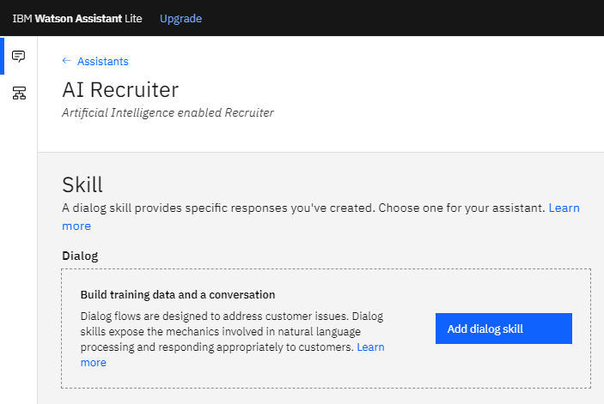
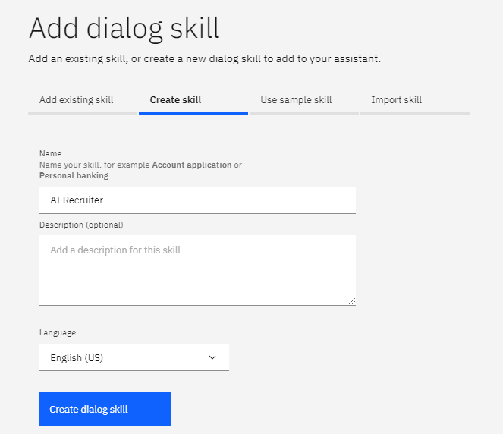

6. In the Intents tab, click Create intent.
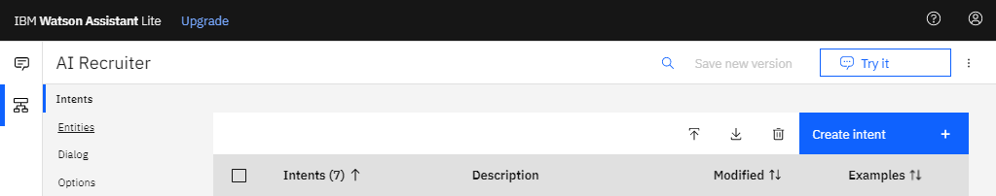

7. Name your intent accordingly and type the examples to recognize this intent and then click Add example and do the same for entities and create intents and entities as per requirements.
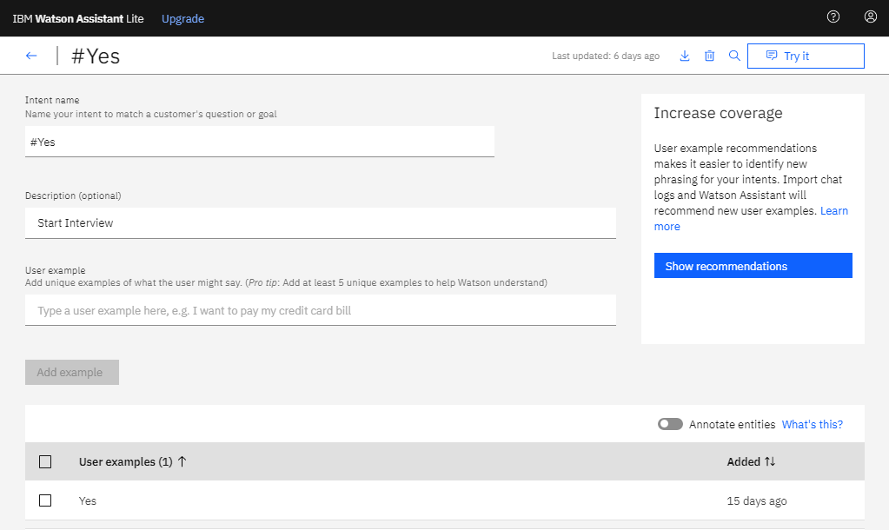

8. In the Dialog tab, click on Add node.
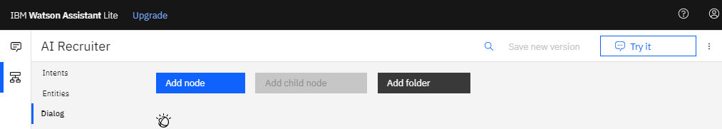

9. Name your node and choose the intent or entity (If assistant recognizes) and type what Assistant has to reply in the Assistant respond section and repeat it for required number of dialog nodes. This creates the Assistant service and can be tested by clicking on Try it (Top Right of Window).
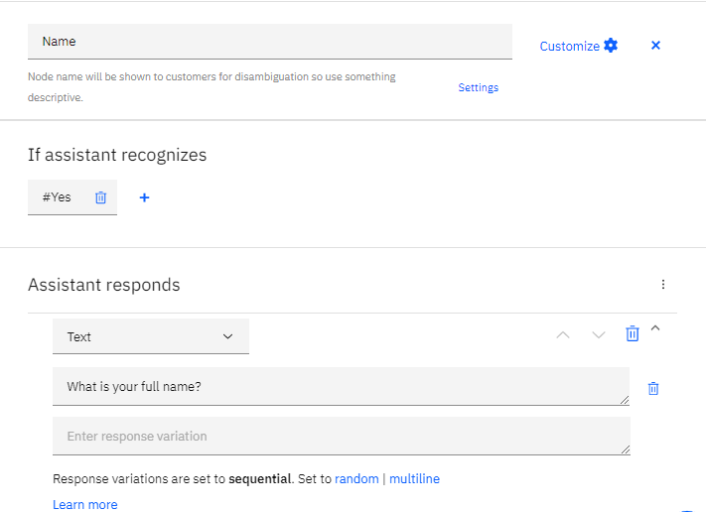

10. Slots and multiple conditioned responses can be enabled by clicking on Customize and switching on them and click Apply.
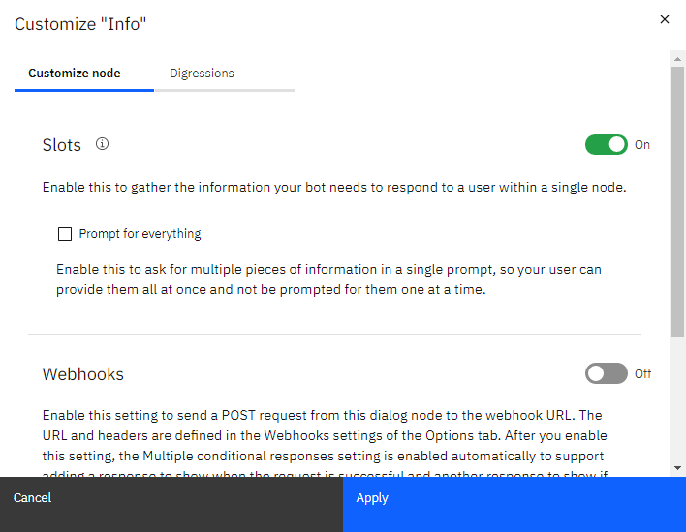
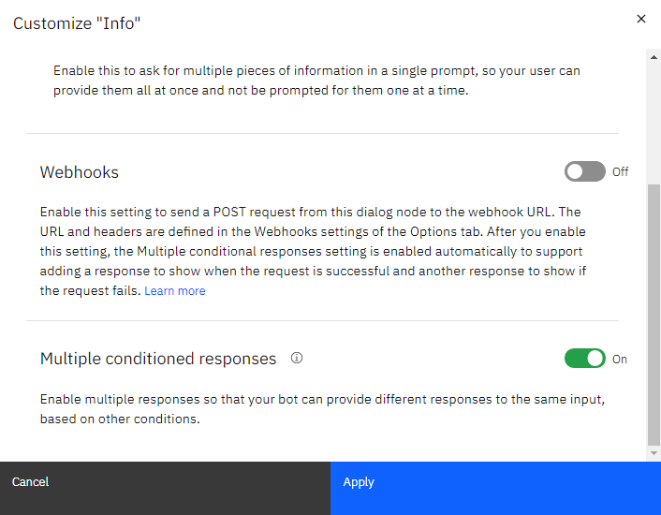

11. By clicking on Try it, we can see the Assistant in action and test it or we can use the preview link to see how it works.
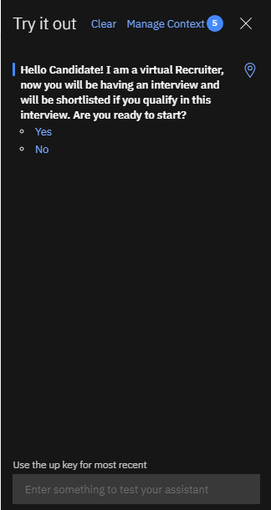

CHAPTER 5
FLOWCHART
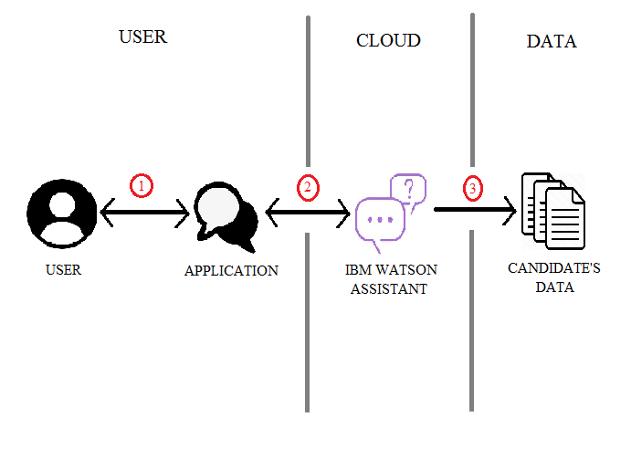

Fig. 5.1 Architecture of Artificial Intelligence(AI) Recruiter

1. The user or candidate interacts with the application and completes the interview screening.
2. The application converses with user based upon the flow of IBM Watson Assistant and asks questions depending upon the candidate’s response. Application acts as a User Interface that provides a way for the user to interact with the back-end servers.
3. The conversation and information about the user/candidate gets stored as data that can be used for reviewing or processing it to get insights and understanding about the candidate.

CHAPTER 6
RESULTS
The candidate can interact with the Assistant and answer the questions and can share their information, skills known, and traits through the user-friendly IBM Watson Assistant that can dynamically change questions depending upon the candidate’s reply or response. The following images show how this process of screening the right candidate is carried out. Finally if the gets selected it notifies the candidate with a message and also displays the candidate’s percentage. And if not selected it displays that the candidate is not selected. Moreover it generates a unique ID only if the candidate gets selected which can be used to make a list of selected candidates with their generated Ids.

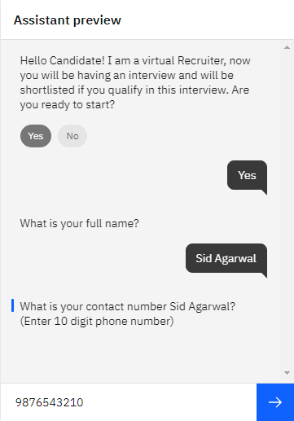

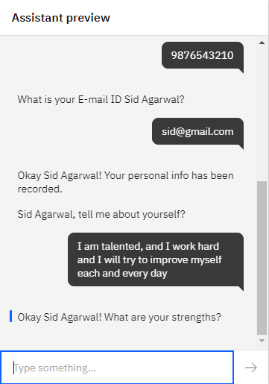
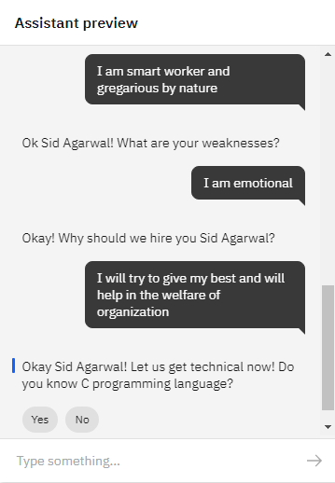
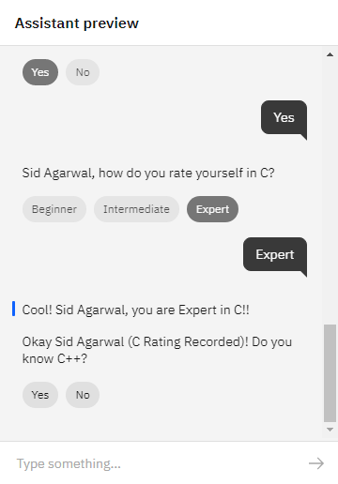
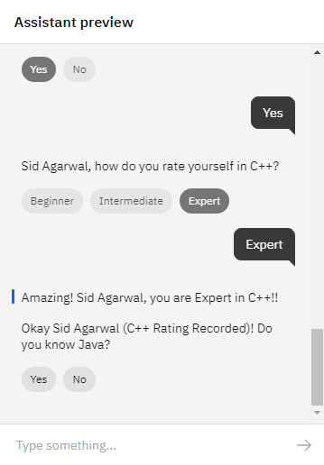
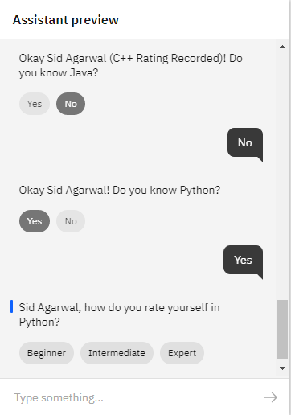
Once the candidate gets selected it gives a notification message that the candidate is selected and generates a unique ID, only if the candidate gets selected.
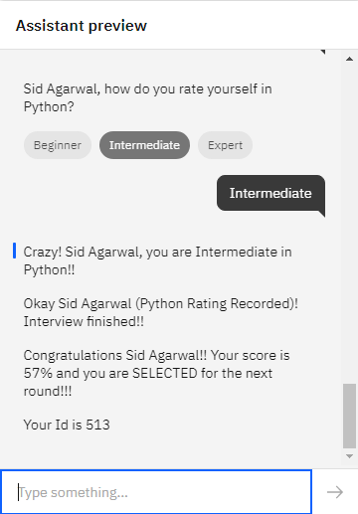

CHAPTER 7
ADVANTAGES AND DISADVANTAGES

ADVANTAGES
- It is cost-efficient and organizations need not invest much in recruiters for picking or selecting the right candidate for the job.
- Reduce the involvement of human recruiters.
- Helps the employers in selecting the right candidate for specific job role.
- It reduces the time needed to screen any number of candidates.
- It can take its own decision depending upon the score of the candidate. However, the threshold score required to qualify can be set by the recruiter.
- Almost all industries, companies can deploy AI Recruiter to help the recruiters and speed up the recruiting process with greater efficiency.
- It reduces human recruiters’ effort.

DISADVANTAGES
- Sometimes these can be manipulated if the working of this model is known.
- It does not consider human emotions.
- Sometimes does not work properly due to clash between the words in different intents.
- Jobs for humans, especially recruiters may be decreased or lost completely.
- Lack of standardization in human text.

CHAPTER 8
APPLICATIONS
AI Recruiters in near future can become a boon to organizations or companies in screening process for a job or selecting candidates for the job directly. Thus it reduces the human effort and moreover helps organization in preserving their resources like money, time and energy and creates a best way to interview the candidates even without the intervention of human more effectively, efficiently and productively. It can also be used by colleges in place of entry exams to select the students. It can be used in different industries like:
- Software Companies.
- Hardware Jobs.
- Mechanical and Electronic Companies.
- Government Jobs.
- And even can replace various college entry exams.

CHAPTER 9
CONCLUSION
For high volume recruiting or scenarios where number of jobs available to number of candidates applied is very low organizations or companies need to interview a large group to select the right candidate. This not only consumes a lot of time but also consumes a lot of money, energy and other resources. According to a survey, almost 65% of candidates’ resumes go unnoticed. Thus, AI Recruiters can solve this issue and can interact with candidates in very short time and bring insights to the recruiter and helps in selecting the right candidate with ease. It also increases the effectiveness and efficiency of recruiters or employers. This can be made possible using AI service like IBM Watson Assistant and can screen the candidates with ease. However these cannot replace the work that a human recruiter can do.

CHAPTER 10
FUTURE SCOPE
AI Recruiter is based on text and typing but in future these can be integrated with virtual assistants like Alexa, Google and can resemble much like a human and makes the interaction more convenient and comfortable. So these AI recruiters can be redesigned more conveniently and can be made hands-free. AI Recruiter can filter out the eligible candidates faster and human recruiters can interview them if needed. This eases the human recruiter and employers’ in either screening or selecting the right candidate for the specific job.

CHAPTER 11
BIBILOGRAPHY
REFERENCES
- https://cloud.ibm.com/
- https://ideal.com/recruitment-chatbot/
- https://youtube.com/ (IBM Channel)

